**1st Week (Done on 14/4/2023)**

For the first week we only had one group meeting very late on Sunday as we were busy with other assignments and work. We have decided that each person would generate one game idea and showcase to each other what the game is about the next week. Here is my game idea that I will be suggesting to my groupmates.

**General Scope**

This game is a board game where players are in a space station invaded by monsters which is going to explode. The space station is filled with high-tech gadgets and tools that can be used to aid or sabotage other players. Players must quickly get to the spaceship to escape and survive. (Ending tile)

Game is played in a n x n (preferably 6 x 6 but may increase as player size increases) modular board game where each square tile other than the starting tile and ending tile needs to be shuffled and pieced together faced down to form the board. Starting tile begins on the bottom left side of the board and ending tile is on the upper right side of the board. There is a deck of tech cards for players to use which may be used for saving yourself or another player or even harming another player!

The game can also include a explode meter which determines when the space station will explode and everyone who is not teleported away will die/lose. The space meter has 10-15 bars and once every player has moved one turn the space meter goes up by 1 bar.

Example of board: 

**Game Rules & Instructions**

1. Each player would draw 3 tech cards from the deck and decide who to move first.

2. Players put their character on the starting tile.

3. Only on the first turn, the adjacent tiles are revealed for all players, and they can vote for a change of tiles, just in case both tiles are danger tiles.

4. The player moving can only move to adjacent tiles of their character.

5. When the player moves to a tile which is not shown, flip the card over and show what type of tile it is.

6. Tech card can be played anytime by any player whenever the player moving has moved.

7. First player who reaches the spaceship tile (ending tile) gets first place and subsequent players get their places too.

8. Keep track of the explode meter as once reached the space station explodes and those not teleported will lose!

**Ideas on tiles and action cards**

Landing on each tile may have special effects which may be beneficial or harmful.

Tiles:

1x Launch Bay – Starting tile for the placers on the bottom left.

1x Spaceship – Ending tile for the places on the upper right.   
8x Normal tiles: These tiles do not have any special effects and players can move through them without any consequences.

4x Observation deck – allows players to view all adjacent tiles.

6x Monster encounter – Player moves back 2 position he was in. Afterwards, replace the monster encounter tile with another tile faced down.

4x Teleportal – Allow players to teleport to another teleportal tile, if no other teleportal tile exists, this tile has no effect.

4x Tech Cache – Allow players to draw a tech card even if they have 5 tech cards already.

2x Critical System – Increase the explode meter by 1.

4x Electrical Hazard – Players are stunned and would not be able to move on their next turn as well as using their tech cards.

4x Unstable floors – The player that lands on this tile can either choose the tiles in the same row or the same column being affected as well as the direction. When decision is made, the tiles shift one step to the direction chosen and a new tile will replace the tile being removed. Ensure that the column or row chosen does not affect the starting or ending tile.

4x Quantum Entanglement – Choose 2 tiles in the same row or column and swap their places. The tiles chosen should not be the starting or ending tile.

4x Gravity Shockwave – Players that land on this tile gets bounced off to a chosen adjacent tile, afterwards the effect of the adjacent tile will be applied if any.

1x Blackhole – Player encounters a blackhole and has a chance of being sucked into it. Roll a dice to determine to result, old means the player is sucked into it and even means the player remains.

Tech Cards:   
5x Plasma Rifle – A powerful weapon that eliminates monster in its path. Can only be used on the wielder himself.

5x Gravity Gun – A powerful weapon that pushes or pulls another player or the wielder himself into an adjacent tile. a

5x Radar Sensor – Scans the surrounding adjacent tiles of the user. (Take a quick peek)

5x Disruptor Field – Disrupt one player’s move for one turn.

5x Force Field – Protects the user from all dangerous tiles and other player’s tech gadget.

**2nd Week (Done on 21/5/2023)**

For the second week, we have decided to use Ching Heng’s game idea called “Etheria”. To summarize the game, “Etheria” is a competitive board game where players aim to earn the most points by bidding for noble cards, trading resources, and participating in special events. Each player belongs to one of four factions and strategically navigates through phases to maximize their score. We have play tested the game on 20/5/2023 at Ri Sheng’s house with some paper rectangular cards with the type of noble, resource, and event written at the front. As we playtest through the game, we encounter some problems such as not having enough resource cards on each player hand, punishment for losing a bid is too low, trading occurs too frequently, reaching the end game takes too long. This are the major problems along with some minor problems like unbalanced event cards for noble actives.

1. Insufficient resource cards on each player – Originally, each player draws 5 cards at the start of the game and draws 2 more cards once their turn ends. We play tested with this originally and found out that by round 4 no one has enough to bid for more cards unless the draw event cards that allows one individual to draw more cards which is a bit unfair, and luck based. Now we decided to increase the starting card number from 5 to 6 so that players can participate in bidding if high-cost nobles come out, where they can choose to “All-In” or save for later nobles. Starting with 5 cards would mean lesser chance or meeting the requirements for bidding of higher nobles in the first round. Now we changed the rate of players getting resource cards from 2 resource cards for the player who ends his turn to every round after the first, all players draw 3 cards at the start of each round. Firstly, card number increases from 2 to 3 which means more participation in bidding which we play tested it and it worked perfectly, as there are fewer rounds where nobles were skipped. Secondly, it is more consistent as all the players get their resource cards at the same time instead of getting it after their own turn. This is fairer as for example, after finishing my round and that round, I chose not to bid, so I won’t lose anything and get 2 resource cards which would obviously be more than the other players ahead of me, hence I would have a higher chance of winning the next few bids until the next round. Hence changing it to a more consistent way of getting resource cards. We also play tested it and found that when more players participate in bids for high nobles it is more thrilling and exciting as the point difference is lowered compared to someone who is just dominating other players.
2. Punishment for losing a bid – So this is another major issue as we play tested the game the first time. We found that the punishment for losing a bid is a bit too low especially for higher nobles. The punishment was discarding 1 card for each player who participates in bids and loses regardless of the noble being bided. We changed it so that as the noble cost/rank goes higher the punishment would increase as there is not much risk if a player just loses one card with a chance that nobody bids for that high noble and he himself gets it. So, we changed to losing a bid for faction heroes would discard 3 cards, losing a bid for dukes would lose 2 cards and the rest would be 1. So, for higher nobles, the reward goes up, and the risk should also go up, so we made it that way which we play tested and its more fun and exciting when bidding for expensive nobles.
3. Trading too frequently – So this is stated by Mr Oon himself that the trade takes too much time if each player gets to trade after each player’s turn. We play tested this and it indeed took too long so we have changed it to the players can trade once for each round from round 3 onwards. This makes the trading more balanced out as well as not taking too much time. We decided the round number 3 to start trading because that is when players get nobles from any faction which would make people want to trade for their own faction noble. We play tested this and it was just right as not much time is taken and the trading was not too little and not too much.
4. Reaching the end game takes too long – This is a problem that we haven’t decided how to solve yet. I suggested to them that we should remove some low-ranking nobles (dukes and below) to make the total number of nobles be lesser. Because to reach the end game, the deck of noble should be entirely drawn, and each player would tally up their points. On the play testing day, we had 64 nobles which we never played finish, so I have decided to lower the number of nobles to 40 to 48 which is much lesser hence faster to end.

To summarize this week was for play testing and we fixed a lot of problems that affects the game. We are just left with some minor problems such as the naming of low-ranking nobles have duplicates as well as the abilities of event cards and nobles.

**3rd Week (Done on 22/5/2023)**

Today in class we made some major changes to the game, and we agreed to finalize this unless further notices are made within our chat.

First major change is the trading phases. We have decided to make trading a special event when a black card is drawn from the noble deck. Upon drawing the special event “Trade Mandate”, the player who drew the card is allowed to use the card on that turn or keep it or later use. The “Trade Mandate” card forces a player to participate in a trade with you, trading nobles of the same cost (faction heroes are now not allowed), and the same procedure of trading occurs where players will indicate whether to rig the trade or agree to the trade on the mark of betrayal coin (one green one red square tile for decision). Now the trade does not award the player any points anymore.

Second major change is the number of noble cards. After decreasing the number of noble cards to 48, we still find way too much and way too many possibilities may occur such as repeated getting the nobles of the same faction which may affect the end game. Hence, we have decided to lower the number of cards to 24 with 6 for each faction, 1 faction hero, 3 dukes, and 2 marquess. This will make the game smoother and more fast paced which fits well with the other changes that we made today, as reaching the end game is faster and more exciting.

Third major change is the end and win conditions. So currently we have 3 end/win conditions. First one is the noble deck is depleted and the game ends where everyone will tabulate their points and the highest wins. Second one is when the player has 8 nobles from any faction, it will be the last round and after that round players will also tabulate the points. Third one is a win condition, when a player has 4 nobles of his/her faction, he/she wins the game. I suggested the number 4 because there are only 6 nobles of each faction in the noble deck so 4 seems like a reasonable number which does not seem too easy or too challenging to achieve compared to 5 or 6. This also makes the game more intense when players accumulate more of their own nobles and other players will try to stop the players from getting their own nobles, which increases bidding activity other than their own nobles.

Fourth major change is that players can only hold up to 10 resource cards on their hand, players draw 1 resource card when they do not bid and patching of punishment for losing a bid. As the game’s paced fastens today, due to the new end/win conditions added, players who do not bid are at a loss as other players will be getting more nobles which will help them in the mid to late game since they can activate the end/win condition anytime, putting pressure on the players who no not bid early. Maximum of 10 cards per player hand is also implemented hence players who do not bid cannot stack up too many cards to go for the many higher nobles in a row which has abilities that will impact and change the game. Therefore, players would be rewarded with 1 resource card if they do not bid as it will balance out game for the bidders and non-bidders. We have decreased the punishment for bidding for faction heroes from 3 to 2 as discarding 3 resource cards seem too many as now resource are key to the game and it is a much fast paced game compared to last time.

Other than these major changes, I have patched and removed some event effects as well as the naming of some nobles and generated all the images needed for this game using Bing Chat AI to generate images. The images are contained in the zip file and portfolio for visualisation purposes.

Example of some images:

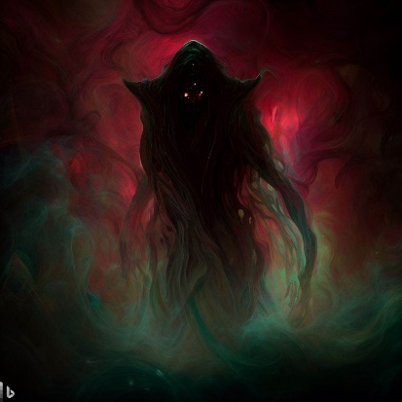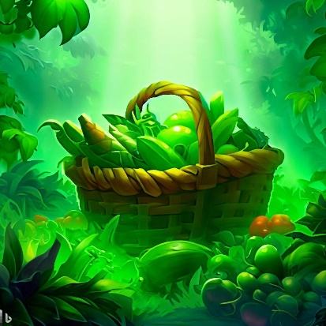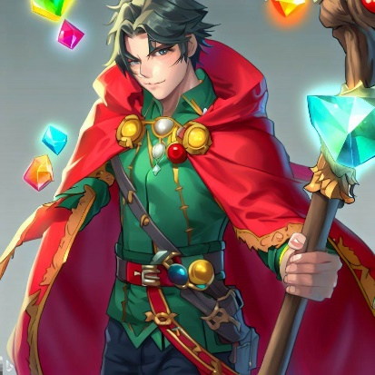



**3rd Week (Done on 25/5/2023)**

From 23 May – 25 May, we have already finalised everything and gathered all the materials needed to make the actual game. For designing of the cards, it was done mainly by Ching Heng and Jeremy where they used the images that I generated and put them onto the card with the details on the card. The tool they used was Adobe Illustrator to design the card shape and card details and printed out later by Ri Sheng.

Here are some examples of the cards:

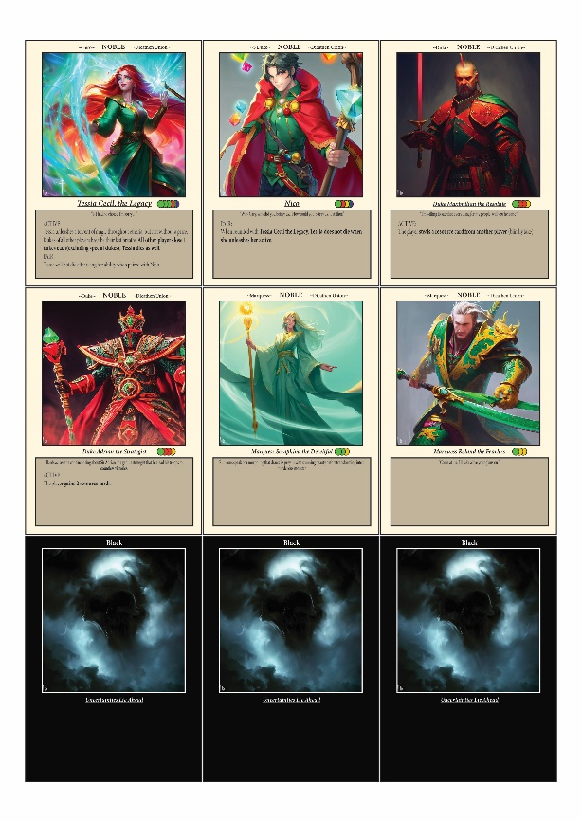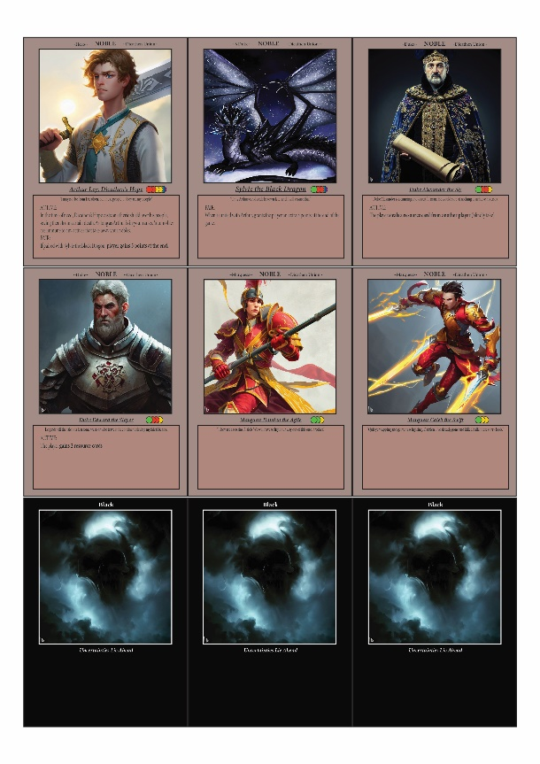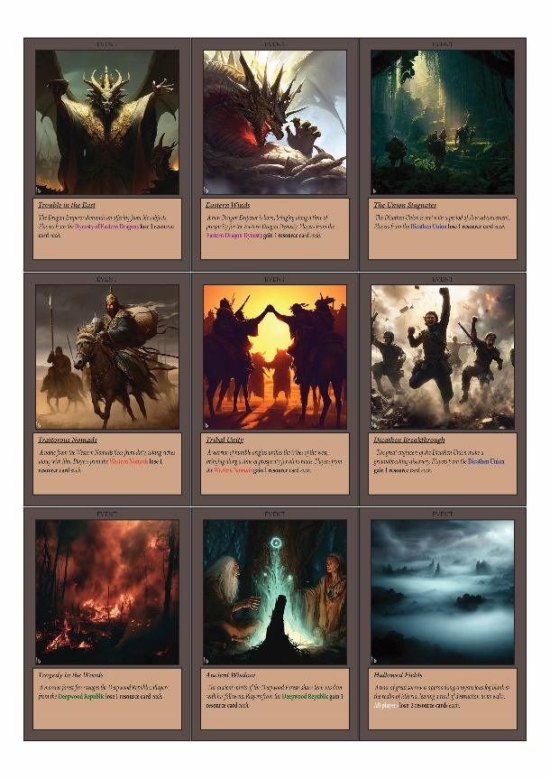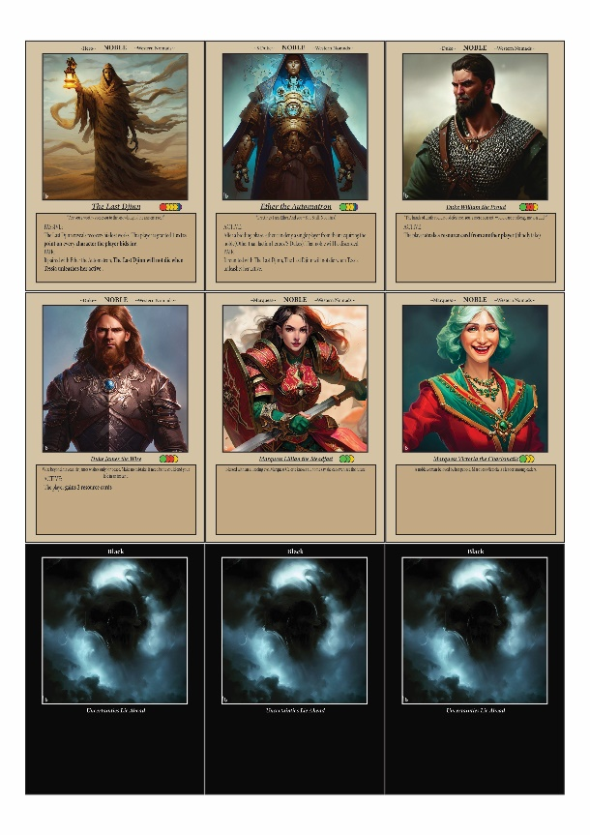

There were some errors on these cards such as the name and the explanation of the cards which we will resolve later. These cards are prints and cut by Ri Sheng where he slots the different type of cards to the respective coloured sleeves. Red sleeves for resource cards, orange sleeves for noble cards, black sleeves for event cards and purple sleeves for faction cards.

**3rd Week (Done on 26/5/2023)**

Today we have decided to meet up at Ri Sheng’s house again to do the final play testing, rulebook, and video pitch. They have decided to play test 3 players while I do the rulebook. So, for the rulebook, I have used Adobe InDesign which is quite a useful and amazing tool for designing the rulebook. While designing the rulebook, I have decided to include a background image for each rulebook which represents the fantasy land of “Etheria”. I have also spitted the rulebook into different sections which includes: “Introduction” – Explains the theme and main parts of the game, “Component” – which shows the material needed for the game, “Setup” – which basically means the basic setup before the game starts, “Game Play”, “Rules”, “Bidding Phase”, “Event Phase”, “Trading Phase”, “End Condition” – which all shows how the game should be played, “Scoring System” – which shows how the points should be tabulated at the end, “Information On Noble Cards” – which outlines the important parts of the noble cards for the players. There are some other aspects I include which includes the usage of “Fantasy” fonts such as “Trajan Colour”, “Old English Text MT” and “Garamond Italic”. I have also included the age range, range of players and estimated time for the game.

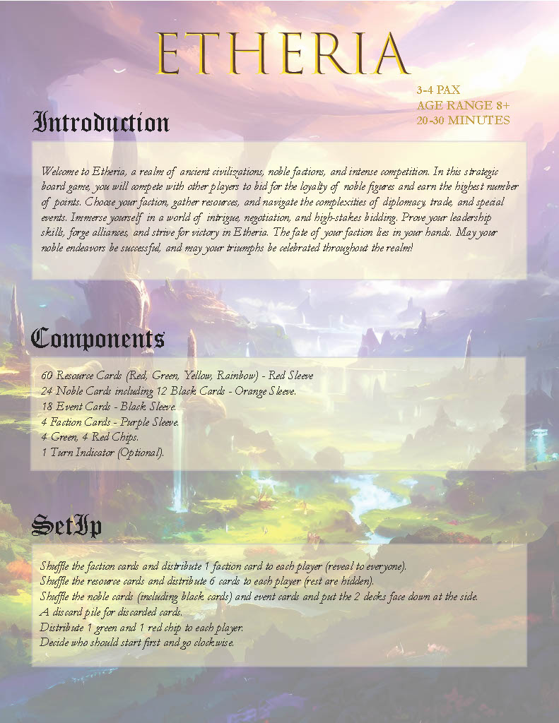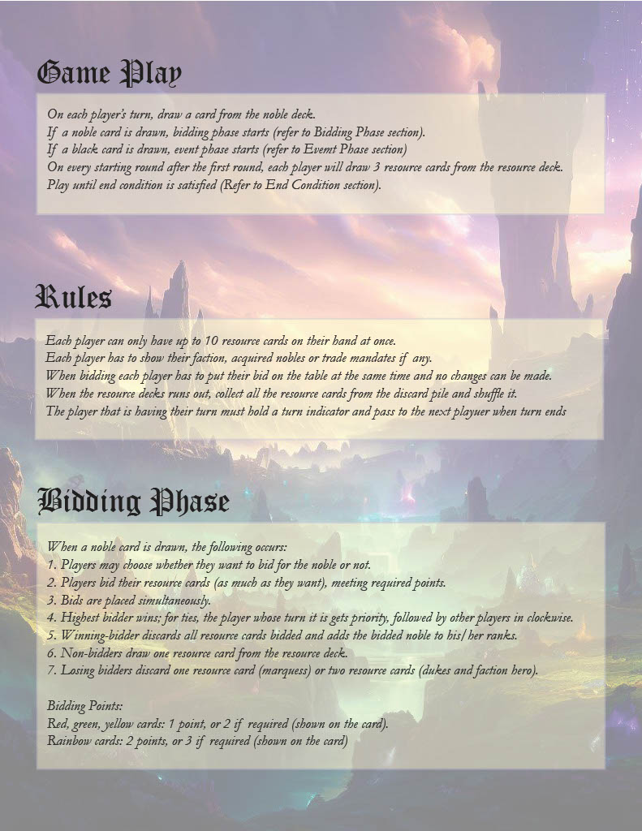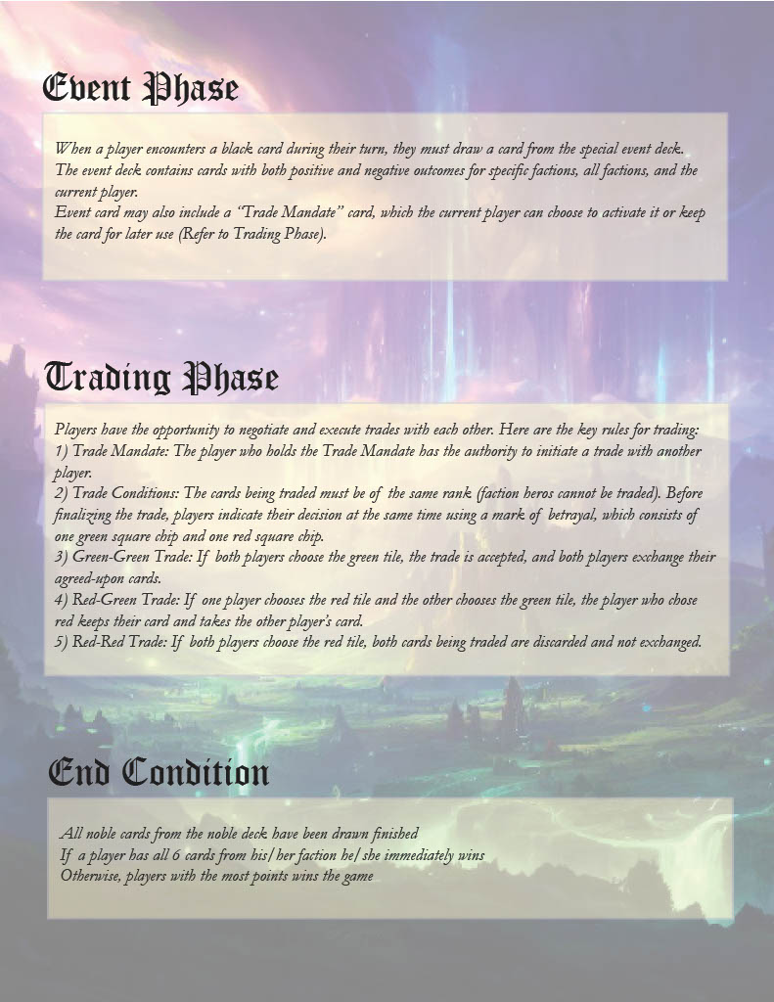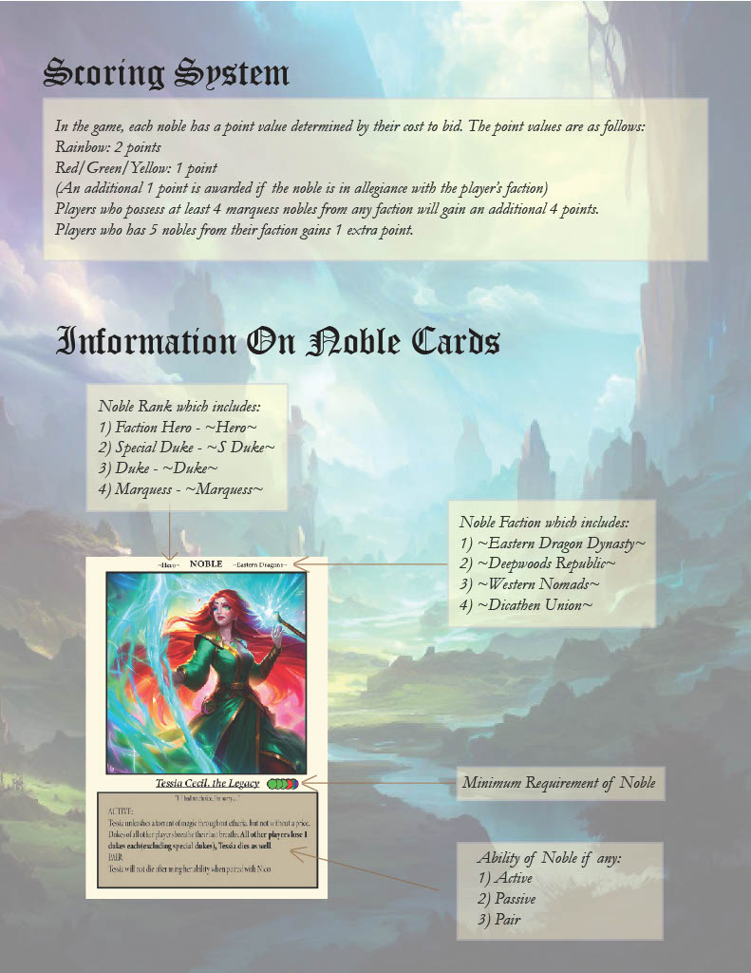

One thing we changed is the point counting system, so now it’s not based on the noble rank but how much the noble bidding cost is. So, for rainbow, it will count as 2 points and other colours (red, yellow, green) will be counted as one. This is to ensure to mainly ensure that there’s a gap between dukes and special dukes as special dukes require more cost hence, we decided to change to this making the special duke more valuable as some of the special dukes are useless without their pairs which may be inferior to normal dukes therefore the change.

We have also made the video pitch showcasing the important parts of our game such as the setup, bidding, event, trading and drawing of resource cards stage. Ri Sheng will be editing the video and adding voiceover to explain how the game is played and why the game is fun (marketing the game). With that we have completed this assignment, it was very fun to design my very own board game with my friends.

**4th Week (Done on 29/5/2023)**

So, this week is the presentation and demo week for our board games. For our presentation we first had to show the video that we have prepared while the video is showing we have to set up the game for the team that is playing our game, which is Team 7, Vernon and Shane’s group. For the explanation, Ching Heng explained most of the important parts such as the different types of cards, bidding phase, event phase as well as trading phase. For me, I answered some minor queries asked from other people such as what is done when there’s a tiebreaker for the bidding, which goes from the person who drew the card clockwise. I also give some suggestions such as why Shane should bid on the noble, which is a duke from Eastern Dragon, since it gives one extra point. There is one suggestion made by Mr Oon, which is to combine the event cards with the noble cards so that the black card would not be necessary, and it would not be so complicated. Mr Oon also suggested that we do not need the trade event as it won’t really affect the game and that the text on it was too small and the colors was not color-blind friendly. The 2 games I like the most are Castle of Despair: Key to Survival and Artifact Dungeon. For the first game, I liked the visuals of the game as it was very high quality, but the rulebook its very long and some mechanics of the game are not so balanced like the number of moves between the killer and survivor so I think that needs to be fixed, one suggestion is to nerf the special abilities of killers the actives and the passives so that it would be more balanced for both sides. For the second game, I like the layout of the game with the hex board which looks very special and it seems very fun just that I didn’t have a chance to try it. The game was said to be 45 minutes with respawns of players which benefits players who plays fast hence it was better to count by the turns. For the game I tried, which is team Tomb of Theseus, I didn’t really understand the game as it seems a bit complicated and the setup was just too long. Overall, it was a fun presentation for me as I get to see other group’s game designs and learn from their ideas. This is the end of assignment 1, I hope to incorporate some things I learnt next time if I ever become a board game designer.